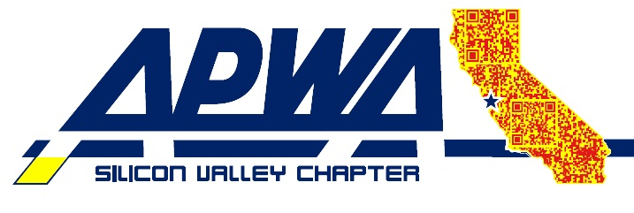

2026 APWA Silicon Valley Chapter Equipment Roadeo
San Mateo & Santa Clara Counties
June 3, 2026 | 9:00 A.M. – 3:00 P.M. | City of San Jose

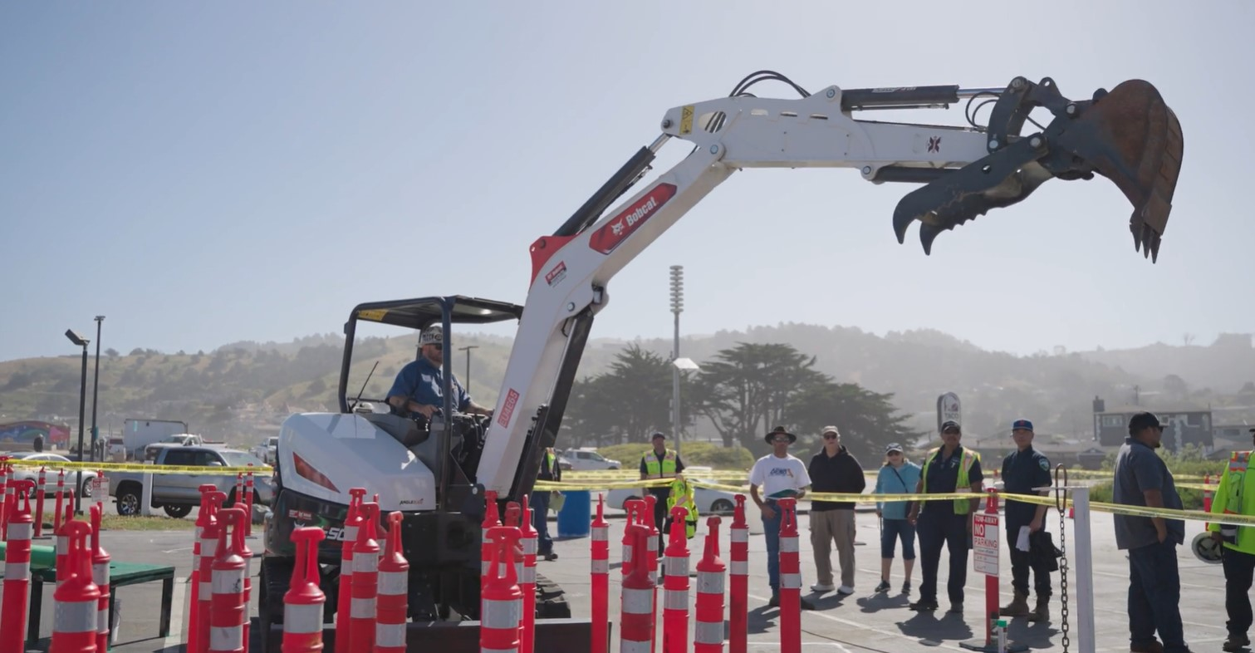

ATTENTION AGENCIES!
Select your top two operators and register by May 25, 2026.

TRAINING CLASSES!
PG&E Safety and Confined Space
(Must attend to receive raffle tickets.)

VOLUNTEERS NEEDED!
Interested in timing or judging an event? Register by May 25, 2026.

VENDOR EXHIBIT/SPONSORSHIPS
Showcase your local product or service! Cost $350. Booth with additional exhibit space available for $450. Sign up here!

EVENT DETAILS
Wednesday, June 3, 2026
9:00 A.M. – 3:00 P.M. (Registration at 8:00 A.M.)
Free to attend
Free lunch for first 150 participants & vendors (must RSVP)!

LOCATION
History Park
635 Phelan Ave, San Jose, CA

Event Questions?
Rey Mendez, rmendez@pacifica.gov
(650) 522-0346
Matt Norris matthew.norris@sanjoseca.gov
(408) 838-8361

Calling All Operators
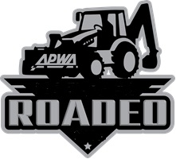
If you are one of the best operators within your agency and you have the skills to compete among the best equipment operators throughout Silicon Valley, then you need to be part of our 9th Annual APWA Equipment ROADEO.

Join us for a day of fun and friendly competition as
operators from agencies throughout San Mateo and Santa Clara Counties face off for recognition as the top agencies in Silicon Valley.

Demonstrate and showcase your skills in the following three exciting events:
- Backhoe
- Mini-Excavator
- Skidsteer
Limit: Two operators per agency.

The chapter will sponsor $1,500 each to the top two winners to compete in the National APWA ROADEO as part of PWX 2026 in Houston, Texas.

The event will include two safety training classes, vendor exhibits, raffle prizes and lunch. Non-competing participants will need to attend both safety classes to receive prize raffle tickets. Please register HERE by May 25 to receive lunch. (Limited to the first 150)

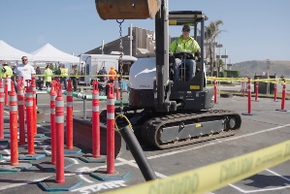
RAFFLE PRIZES
FOR ALL
VENDORS – DON’T MISS THIS EVENT!

FILL OUT, SCAN, AND EMAIL YOUR VENDOR INFORMATION AND CERTIFICATE OF INSURANCE TO Louis Sun at lsun@woodsideca.gov and MAKE YOUR ONLINE PAYMENT BY CLICKING HERE.

Standard booth cost $350 and booth with additional exhibit space is available for $450. APWA will provide a 10’ x10’ canopy, a rectangular table and 2 chairs. For specific requests or inquiries especially in regard to displays for equipment, please contact Matt Norris at matthew.norris@sanjoseca.gov.

VENDOR’S INFORMATION
PLEASE INCLUDE THE FOLLOWING INFORMATION:

COMPANY NAME: ___________________________________________________

MAILING ADDRESS: ___ __________________ ZIP_________

CONTACT NAME: ______________________________________________ __

E-MAIL ADDRESS:_____________________ ____________________________

PHONE NUMBER: __________________ ______________________________

MAIN PRODUCT/EQUIPMENT LINE: ____________________________________

For free lunch, you and other company representatives attending must register at the booth during the day of the event.

Vendors need to provide a COI naming American Public Works Association as additional insured on general liability; $1M Each Occurrence/$2M Aggregate General Liability limit; show proof of workers compensation insurance; $1M Employers Liability Limit and prefer $2M umbrella/excess liability.

Vendors to provide items for the raffle.

SUBMIT YOUR COMPANY LOGO (high resolution jpeg min. 300 dpi) TO ROBERT FONTANILLA AT rfontanilla@cornerstoneearth.com

